Part I

1) Instance launched! Via the website.

2) Logged in with SSH in the git terminal.

3) Connection closed, instances terminated.

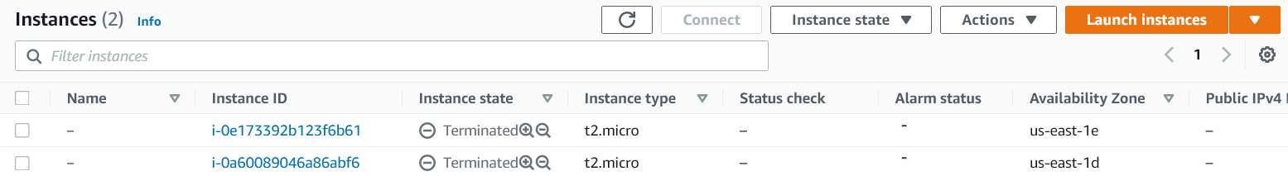

Part II

1) Bucket created.

2) File added.

3) Viewing an object:

4) File moved.

5) Deleting the file:

5-2) Deleting the bucket:

(There is a bucket still there, but that is part of a different project)